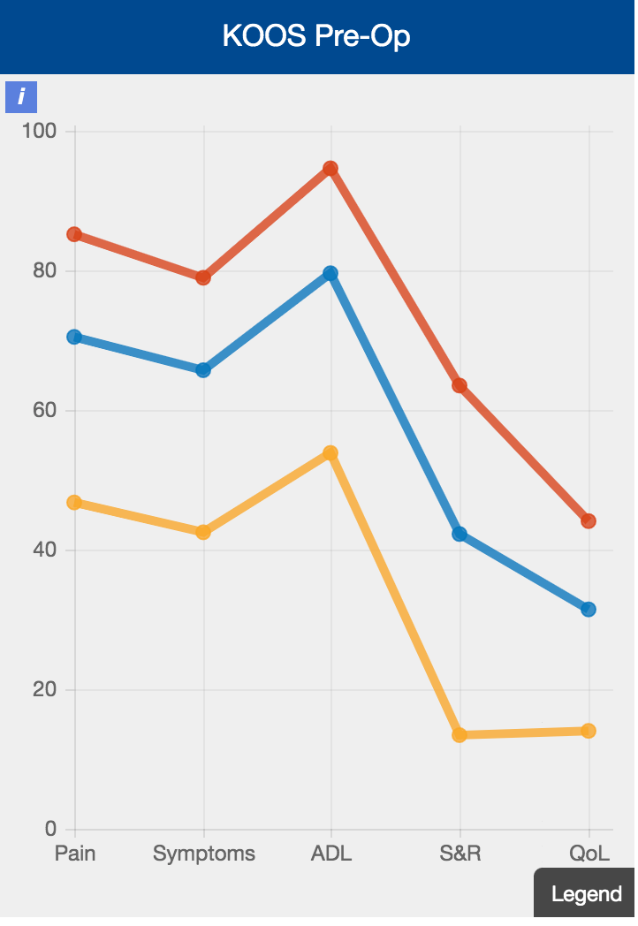 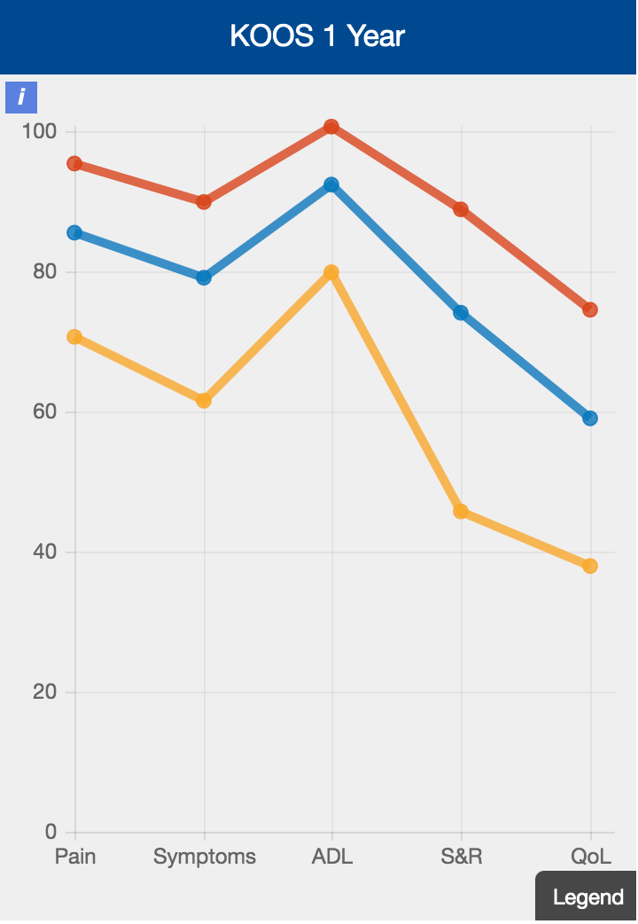

These 2 graph show KOOS scores of patients before and 1 year after their ACL reconstructions

You can see that in all the categories / domains along the X axis – pain / symptoms, activities of daily living, Sport & Recreation and Quality of Life there is an improvement for the scores at 1 year

The blue line Represents my cohort of patients – the yellow and Red lines represent the range of patients in the registry – so it great to see my patients are doing better than average in all domains !

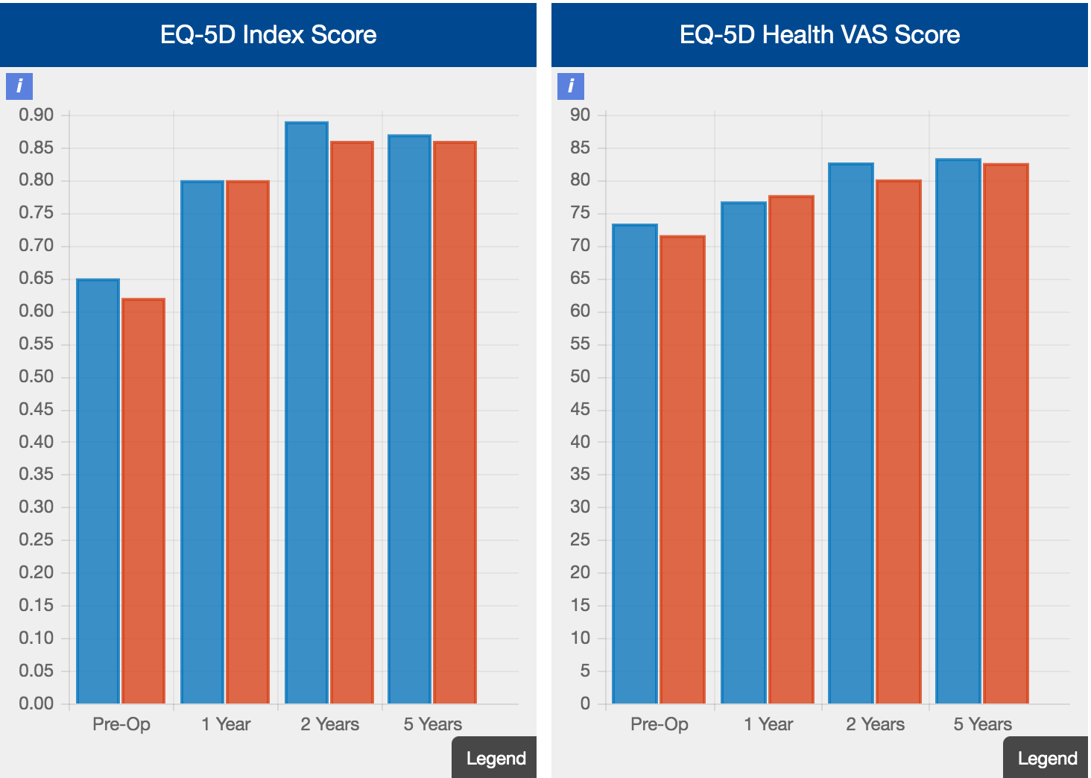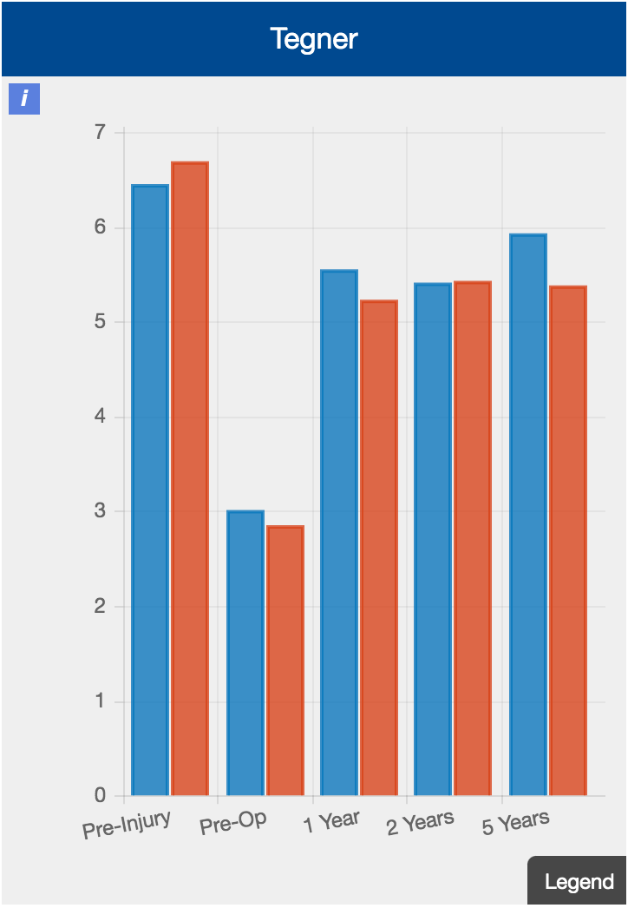

These 3 bar charts show a slightly different representation of how the scores change over time

The EQ-5D are general health scores and the Tegner is a level of sport score are playing.

The blue columns represent my cohort of patients and can be compared to the whole cohort of patients in the registry - the red column

Again its good to see my patients are doing better than the average in all domains