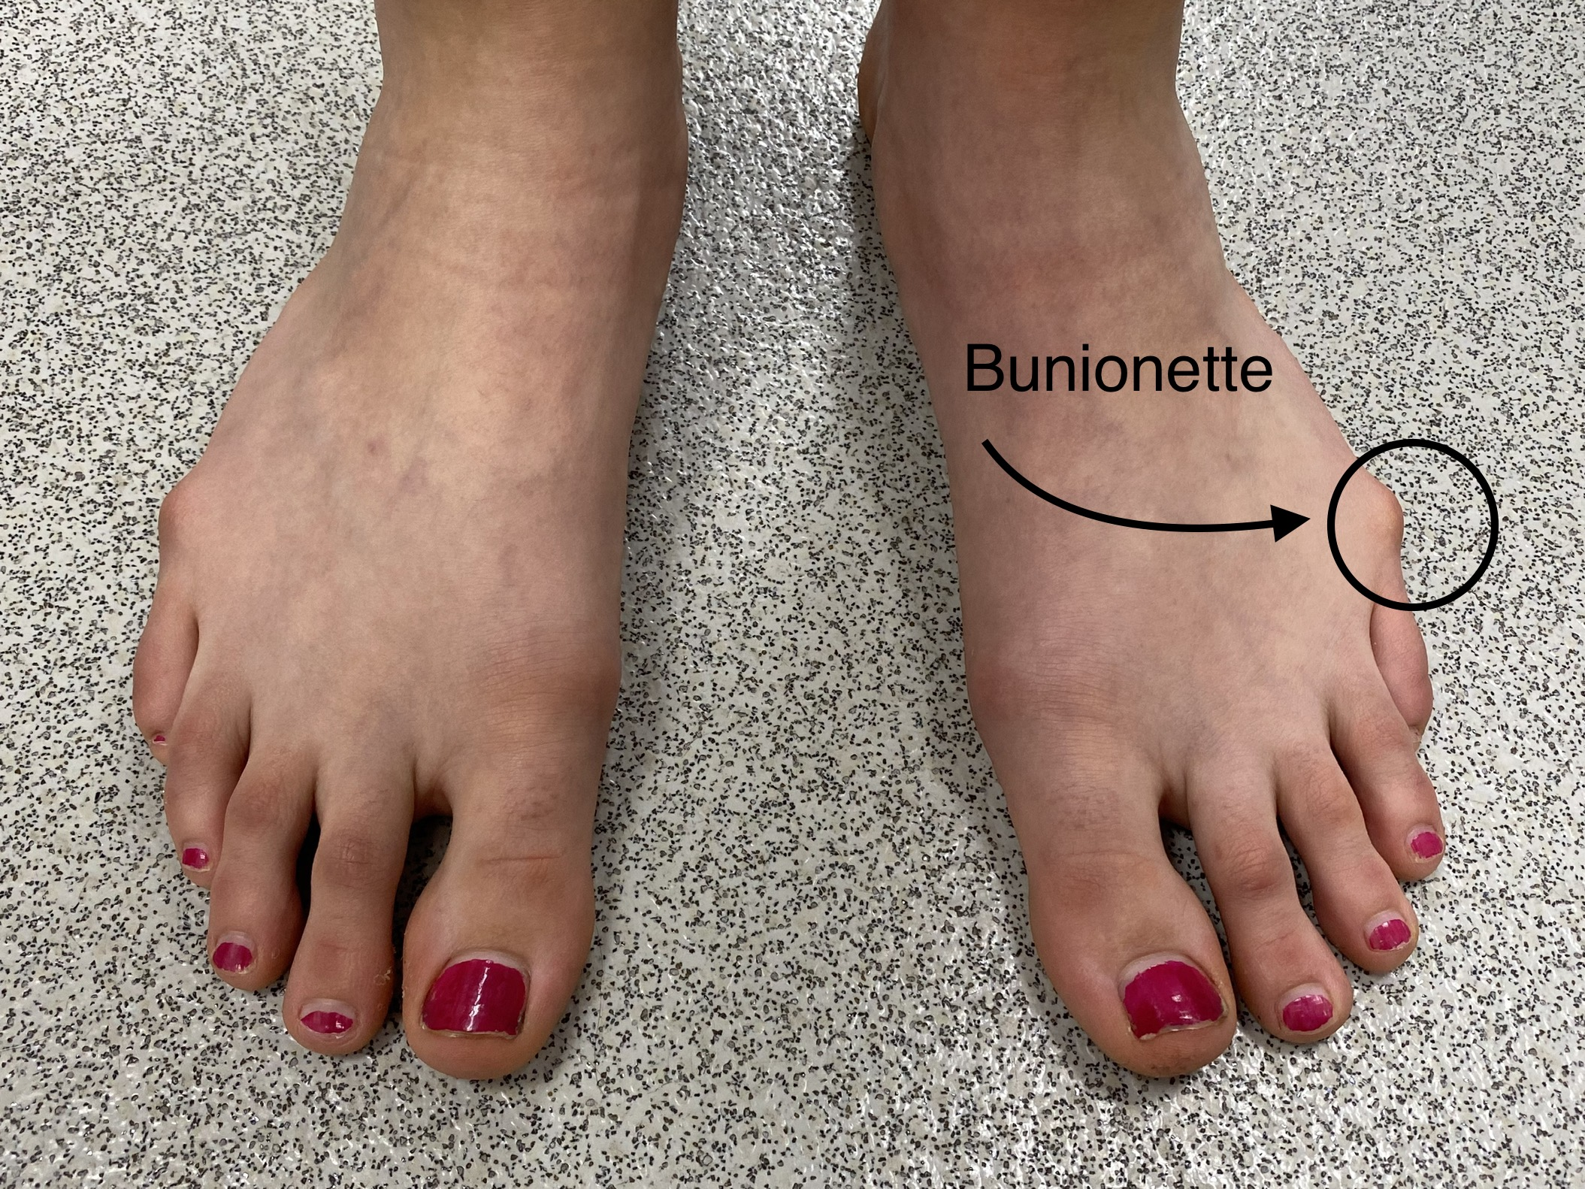
Nev Davies
Reading Children’s Orthopaedic Unit
Information for Families – Bunionette
What is an Bunionette ?
This uncommon condition causes a prominent swelling and bump at the base and outside of the little toe.
What are the symptoms of Bunionette?
The main concern is rubbing and redness associated with the bump. As it gets bigger it can rub more causing pain, hard skin and blistering, as well as difficulties getting shoes to fit. It usually starts to cause problems after the age of 10 years.
What causes this ?
The shape of the long toe (metatarsal) causes the bump. We do not know exactly what causes it but it can affect several generations of the same family, which implies that it is sometimes passed on from parent to child (inherited).
What is the Natural History of this condition?
If the foot remains asymptomatic & pain free we tend to observe & leave well alone. We would encourage moisturisation with cream after baths and wide fitting shoes for comfort.
How can it be treated? Treatment options are quite binary
Option A. Leave alone and observe : we tend to do this in asymptomatic or patients who present younger than their teenage years
Option B. Surgery to straighten the toe : The operation is done under a general anaesthetic as a day case procedure. At the time of consent, we would discuss the procedure in detail with you, the benefits and the risks of the surgery, as well as the postoperative care. Please see the separate info leaflet regarding surgery.

