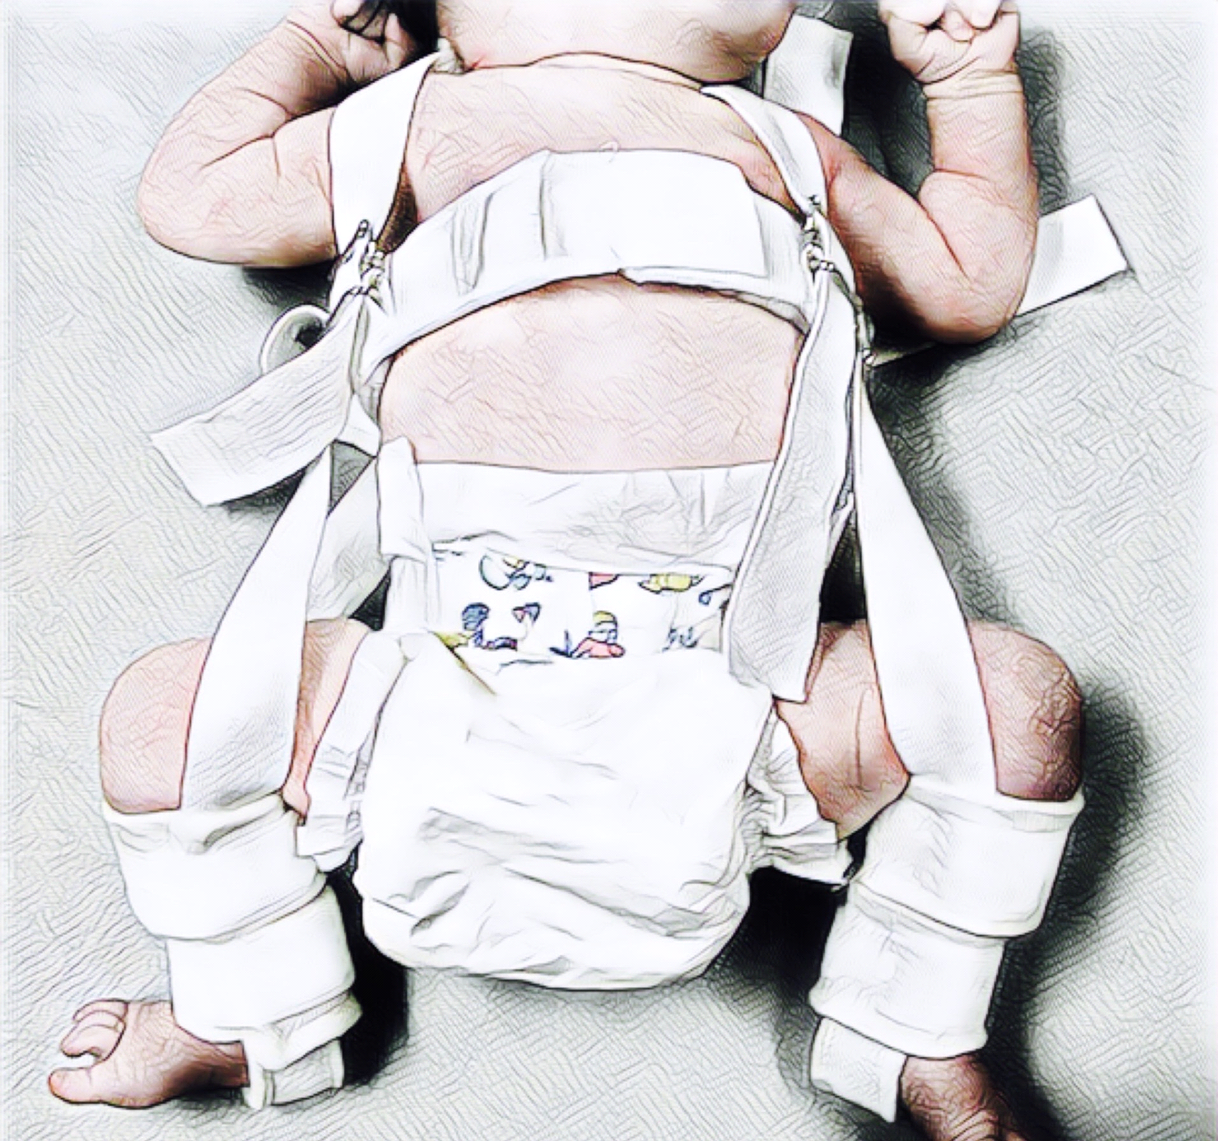Nev Davies - Reading Children’s Orthopaedic Unit
Information for Families
Developmental Dysplasia of the Hip (DDH)
Stage 1 / Plan A: Treatment with Pavlik Harness
What is DDH? (Please also read the general information leaflet)
The hip is a ball and socket joint. DDH is a spectrum of conditions ranging from an underdeveloped shallow hip socket through to a ball that is dislocated (out of the socket). All babies in the UK are checked at birth and at 6-8 weeks to make sure their hips are developing normally. Some babies are at higher risk of having these hip problems. These include twins, breech presentation babies and any baby with a family history of hip problems. In 50% of cases both hips are affected.
Stage One – Treatment with Pavlik Harness (Click Here for Steps Charity Guide)
A Pavlik Harness (see picture above) is used in all babies presenting under 6 months old. It works by keeping the hips in a flexed (bent up) and abducted (outward) position. This helps to keep the ball of hip joint in the socket, encouraging it to develop and become deeper.
Fitting the harness can be a bit fiddly but is usually straight forward. It should be worn 24 hours a day and not be taken off even for bathing. We recommend a using a sponge bath.
What is the follow up?
We follow up babies in harness weekly, with regular Ultrasound scans to check the hips are responding and in joint. If the hips are not in joint, we discontinue after 2 weeks as it can cause more problems. If it is working, it is often used for 12 weeks or so.
Are there any risks?
Rubbing and blistering – sometimes babies’ skin can be sensitive and rub under the straps.
Femoral Nerve Palsy – if the hip is bent up too much it can cause the nerve at the front of the thigh to go to sleep and the leg goes floppy. Although this almost always resolves, we stop using the Harness if this happens and monitor the situation closely.
Failure to get the hips in or developing, moves us on to Stage 2 or Plan B. This is not really a risk, but it is important for parents to realise it can be a possibility, dependent on the severity of the dysplasia and the response to treatment.
We will follow your child up in clinic regularly in the outpatient clinic until we are happy the hip is developing normally both clinically and radiographically (x rays).

