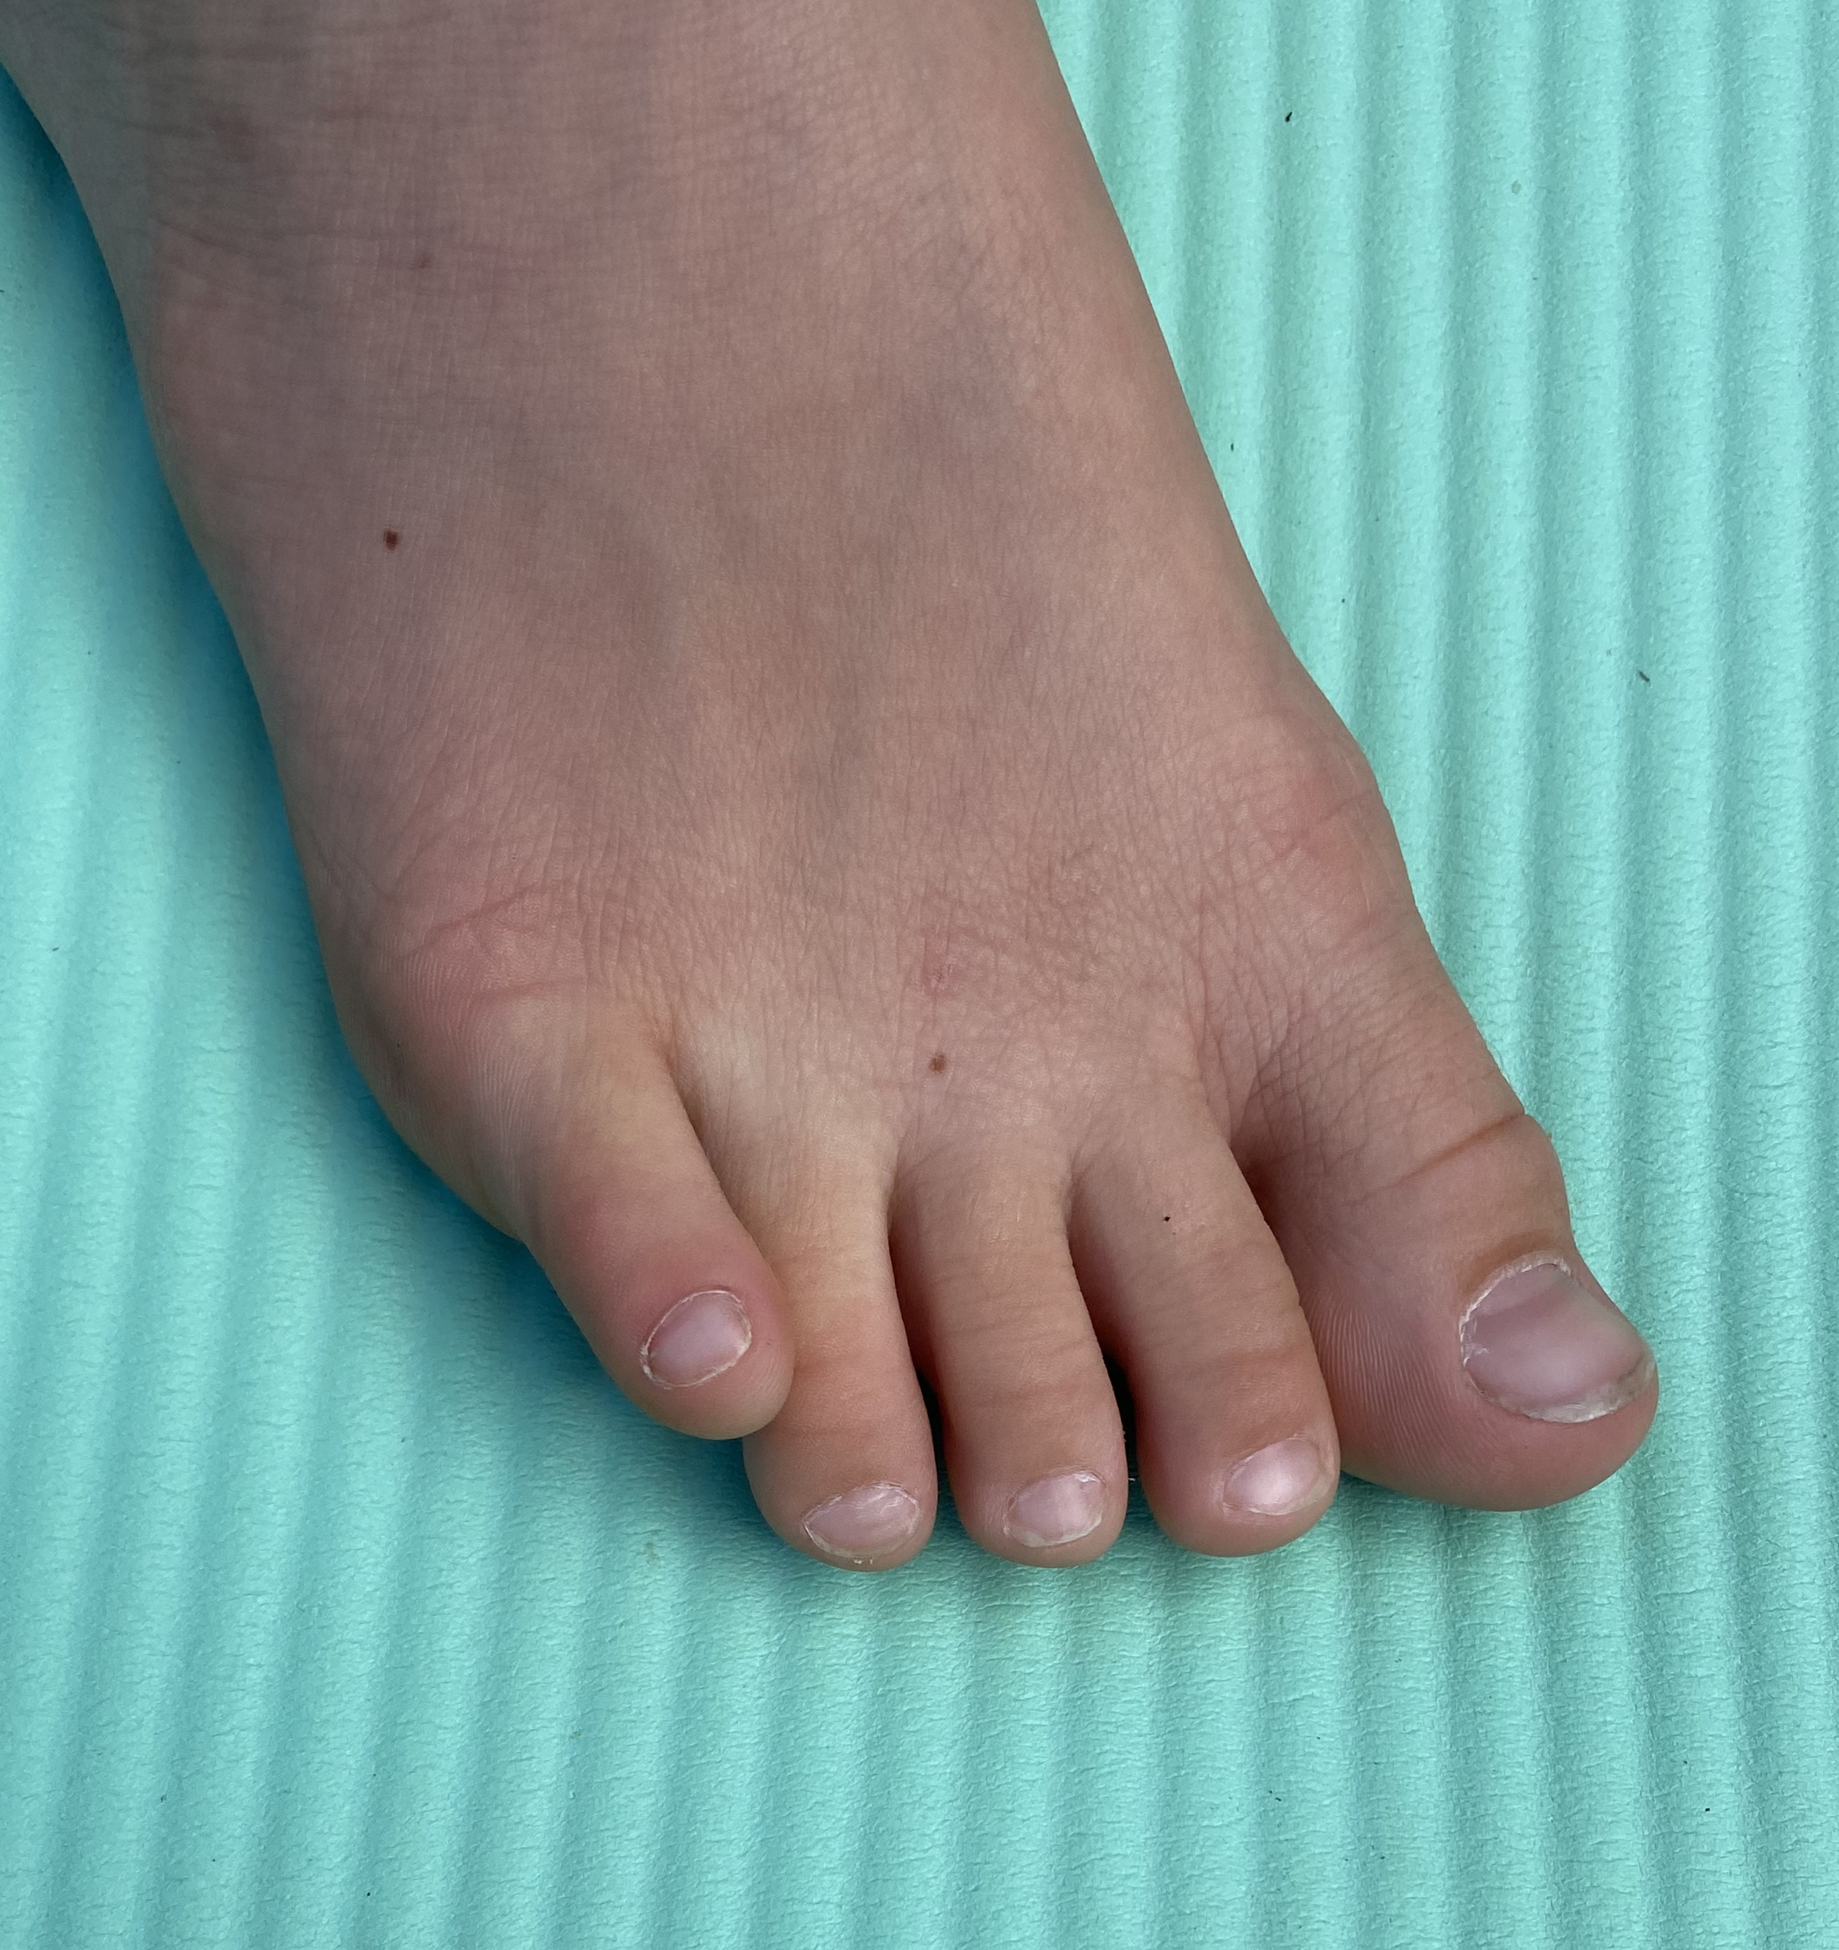
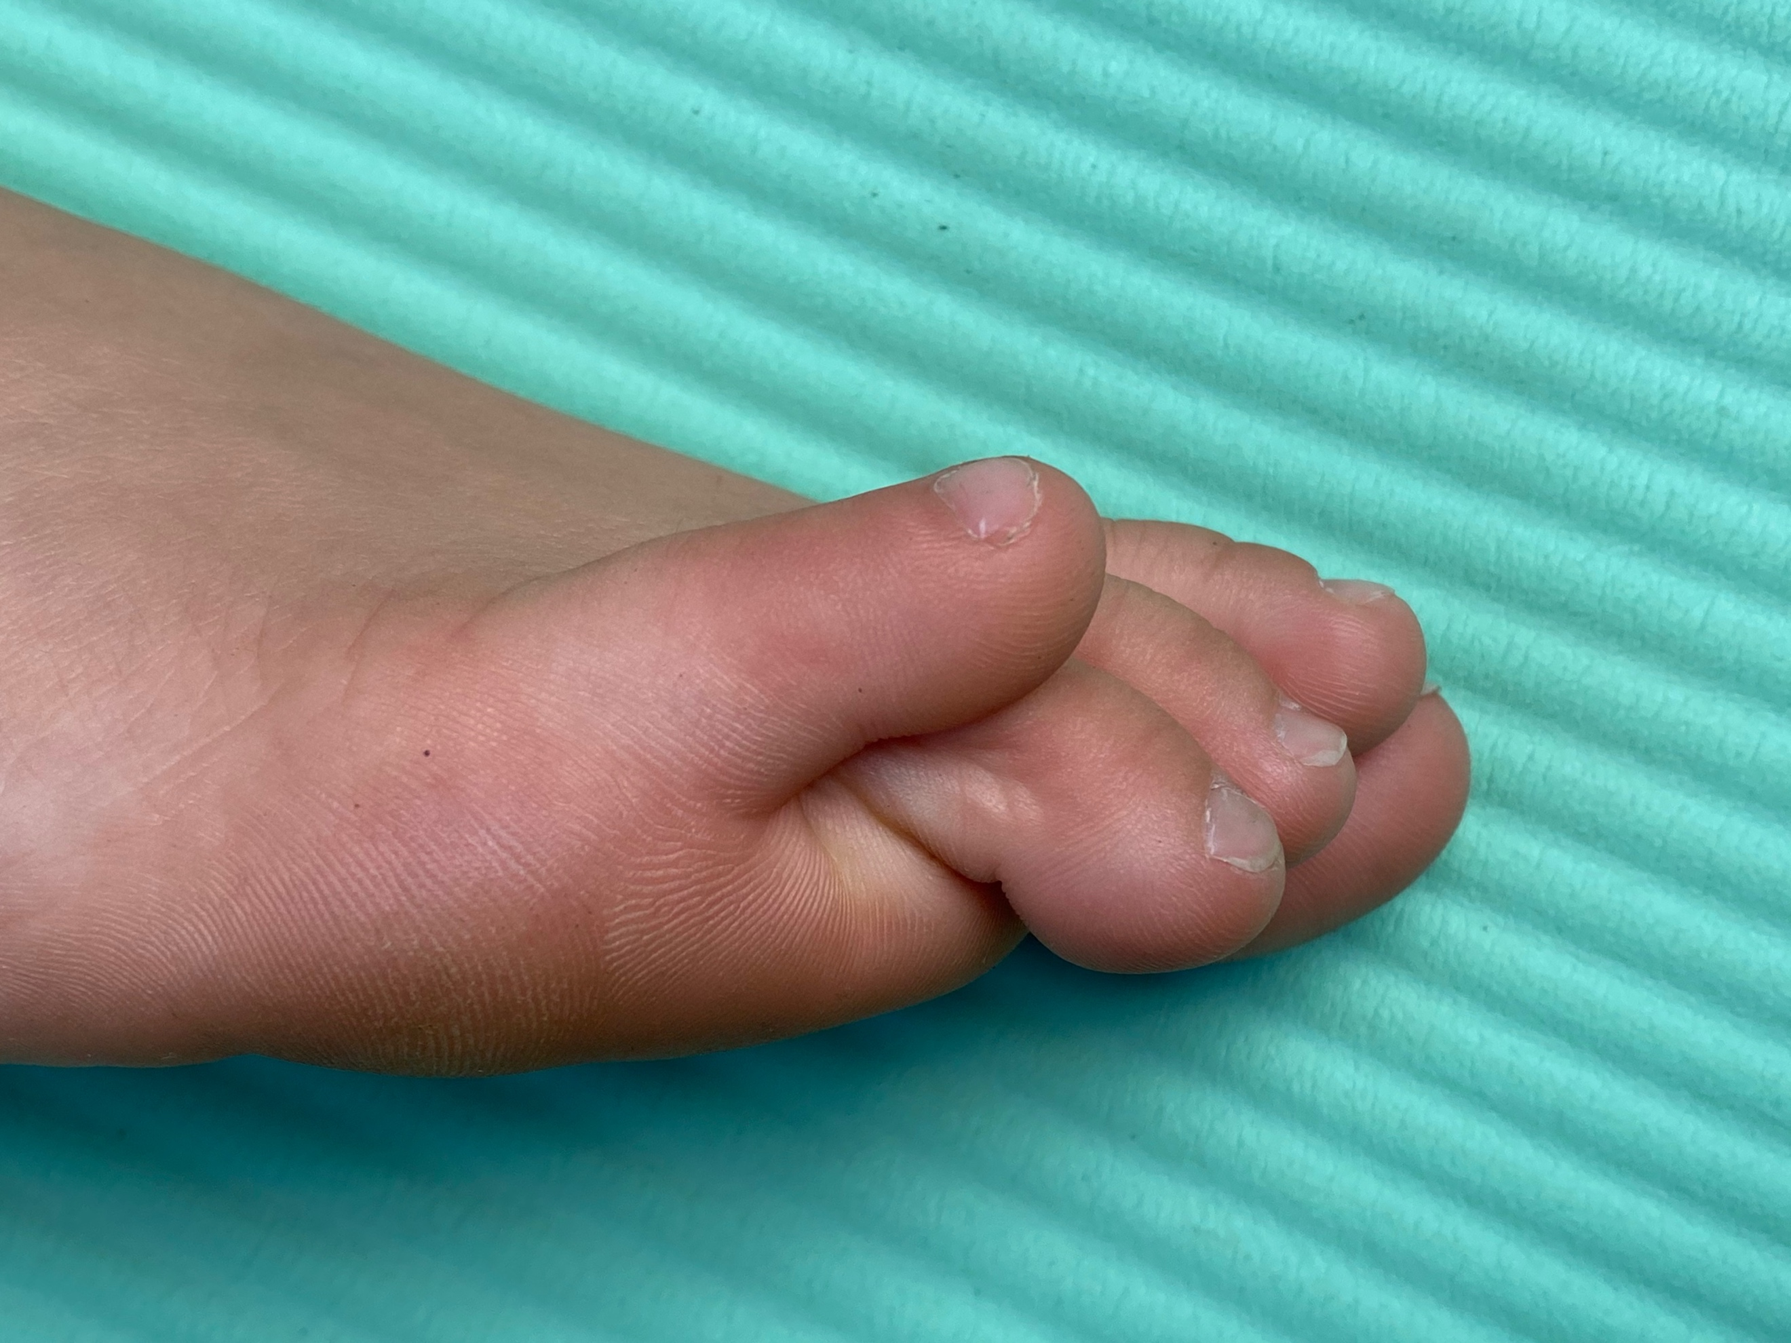
Nev Davies
Reading Children’s Orthopaedic Unit
Information for Families
Overriding 5th Toe
What is an overriding 5th Toe ?
This uncommon condition is usually present at birth but can become more noticeable in the first few years. The 5th little toe sits on top of the 4th toe, curling inwards. Sometimes it occurs just in one foot sometimes in both.
What are the symptoms of an overriding 5th Toe?
The main concern is thelook of the toe, but in the vast majority of people these toes don’t cause too many problems. Sometimes, symptoms such as rubbing, hard skin, blistering or pain can occur, as well as difficulties getting shoes to fit.
What causes this ?
We do not know exactly what causes the toe to sit like this, but it has been noted that the condition can affect several generations, which implies that it is sometimes passed on from parent to child (inherited).
What is the Natural History of this condition?
If the foot remains asymptomatic & pain free we tend to observe & leave well alone. We would encourage moisturisation after baths and wide fitting shoes for comfort.
How can it be treated? Treatment options are quite binary
Option A. Leave alone and observe : we tend to do this in asymptomatic or patients who present very young (under the age of 4)
Option B. Surgery to straighten the toe : If the toe does becomes symptomatic I would usually advise surgery before school age. The operation is done under a general anaesthetic as a day case procedure. At the time of consent, we would discuss the procedure in detail with you, the benefits and the risks of the surgery, as well as the postoperative care. Please see the separate info leaflet regarding surgery.

