Nev Davies
Reading Children’s Orthopaedic Unit
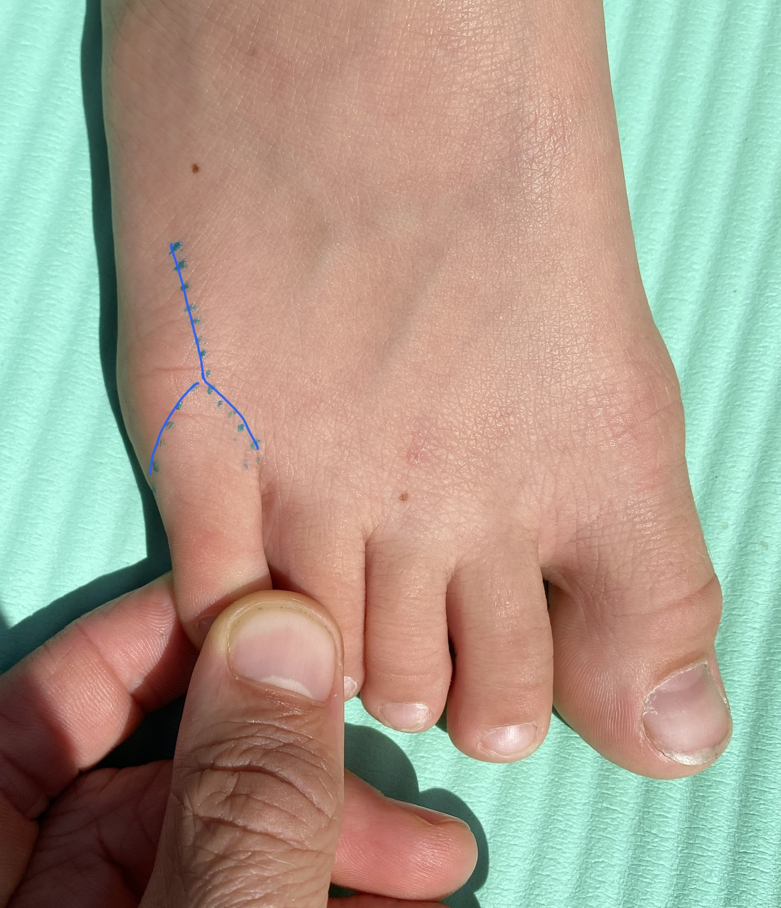
Information for Families - Overriding 5th Toe
Surgical Reconstruction
What is an overriding 5th Toe ?
This uncommon condition is usually present at birth but can become more noticeable in the first few years. The 5th little toe sits on top of the 4th toe, curling inwards. Sometimes it occurs just in one foot sometimes in both.
What are the symptoms of an overriding 5th Toe?
Symptoms such as rubbing, hard skin, blistering or pain can occur, as well as difficulties getting shoes to fit. If the toe becomes significantly symptomatic I would usually advise surgery to straighten the toe before school age.
What does the operation involve ?
The operation is done under a general anaesthetic as a day case procedure. We also numb the toe with local anaesthetic. It’s quite a big operation through a large scar. (blue line on photo) It requires a large soft tissue release of all the tight structures to get the toe straight. I use dissolvable stitches as well as paper stitches and a big wool and crepe dressing.
What is the aftercare?
It’s really important to elevate the foot for 72 hours after the operation. This helps the swelling settle and aid healing. I use a temporary splint (half plaster) with a heel-walking shoe. Crutches are useful but not essential to get around, particularly at school. I see patients at about 2 weeks after the operation, in clinic, to check the scar is healing, and redress the wound. Most patients would slowly wean into a shoe with a nice wide toe box at this stage. Return to sports and activities is at about 4-6 weeks.

What is the Success rates ?
The vast majority of families are very happy with the result. There is always a small chance of recurrent tightness usually due scar tissue build up and the toe reverts to its overriding position. In these cases I would refer to a plastic surgeon for an additional opinion.
What are the risks of surgery ?
The risks of surgery are small and include the general surgical risks any surgery, these include: infection, ugly scar, skin numbness and the specific risks of this operation – recurrent deformity, tendon damage, loss of blood supply to the toe. I will discuss all this in detail with you before we proceed.

