Mr Davies Patients - Post-operative exercises after Knee Arthroscopy (Same Day)

The first 4 exercises should be started on the same day as your surgery & should be done hourly.

The number of times given for you to repeat each exercise is for guidance only. If you are finding that your knee is very painful and/or swollen following the exercises you should cut down the number of repetitions and then build up slowly as your knee allows. If, however you are managing the exercises with no ill effects start increasing the number of repetitions.

1. Ankle Pumps  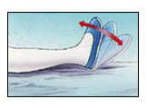 | Move your foot up and down rhythmically by contracting the calf and shin muscles.  Repeat 10 times.  This exercise helps to maintain the circulation in the leg.
2. Quad sets | Tighten your thigh muscles, bracing your knee straight and hold for 5 seconds.  Repeat 10 times.
3. Straight Leg raise  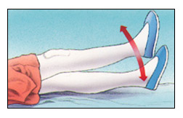 | Tighten the thigh muscle with your knee fully straight on the bed, as with the Quad set.  Lift your leg several inches and hold for 5 to 10 seconds.  Slowly lower.  Repeat 10 times
4. Knee Straightening Exercises  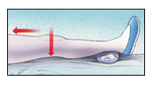 | Place a small rolled towel just above your heel so that it is not touching the bed.  Tighten your thigh.  Try to fully straighten your knee and touch the back of your knee to the bed.  Hold leg fully straight for 10 seconds. Repeat 10 times

The following exercises can be started on the day following your operation. (Day 1 Post Op)

Try to do these exercises 3 times daily. Once again the numbers of repetitions given are for guidance only and you should go by how your knee is reacting to the exercises.

Bed-Supported Knee Bends  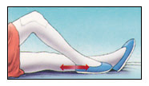 | Bend your knee as much as possible while sliding your foot on the bed.  Hold your knee in a maximally bent position for 5 to 10 seconds and then straighten.  Repeat 10 times.
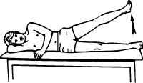  Hip abduction | Lie on your good side. Brace the operated knee and lift up towards the ceiling.  Hold for 5 seconds, then lower.  Repeat 10 times.
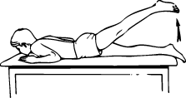  Hip Extension | Lie on your stomach, brace your operated knee and lift it up behind you.  Hold for 5 seconds, then lower.  Repeat 10 times.
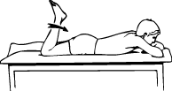  Knee Bends (front) | Lie on your stomach, bend your operated knee as far as possible, and then straighten.  Repeat 10 times.
Hip adduction  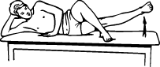 | Lie on your operated side, bend your good leg up in front of you and rest it on the bed.  Brace the lower operated knee and lift.  Hold for 5 seconds.  Repeat 10 times.

Advanced Exercises

Follow advice from your physiotherapist as when to start these exercises.

DO NOT start immediately post operatively.
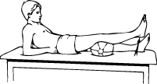  Terminal knee extension | With knee bent over a pillow, straighten knee by tightening muscle on top of thigh. Be sure to keep bottom of knee on bolster.  Hold for 5 seconds, then slowly bend knee to starting position.
Bridging  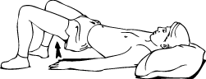 | Slowly raise your buttocks from floor, keeping stomach tight.  Hold for 5 seconds, then slowly bend knees to starting position.
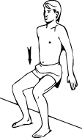  Wall Slides | Leaning on wall, slowly lower buttocks toward floor until your thighs are at 45 degrees to the floor.  Hold for 3 seconds, then slowly bend knee to start.
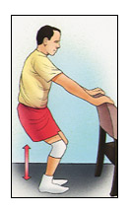  Partial Squat, with Chair | Hold onto a sturdy chair or counter with your feet 6-12 inches from the chair or counter. Do not bend all the way down.  DO NOT go any lower than 90 degrees. Keep back straight. Hold for 5-10 seconds. Slowly come back up. Relax. Repeat 10 times.
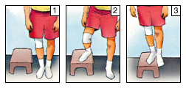  Step-ups (lateral) | Step up onto a 6-inch high stool, leading with your involved leg. Step down, returning to the starting position.  Increase the height of the platform as strength increases. Repeat 10 times.
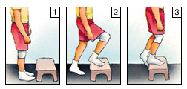  Step-ups (forward) | Step forward up onto a 6-inch high stool, leading with your involved leg. Step down, returning to the starting position.  Increase the height of the platform as strength increases. Repeat 10 times.
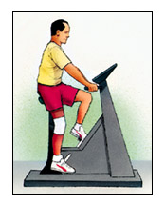  Exercise Bike | If you have access to an exercise bike, set the seat high so your foot can barely reach the pedal and complete a full revolution. Set the resistance to "light" and progress to "heavy." Start pedalling for 10 minutes a day. Increase the duration by one minute a day until you are pedalling 20 minutes a day.

